Arcadit Project Report

@Loltron

Arcadit is a social media app designed to allow its users to interact with other users of the app without any hinderance. The app allows you to post your opinions about topics and these posts are then shared with all the users of the app. The plan was to design an app where the users of the app could interact with each other using private messaging and group chats. However, due to a major bug which was not fixed after days of trying to fix the bug, the option of messaging other users of the app was not available since clicking on the chat was causing the app to crash due to the bug. Another major bug was with posts. The pictures that were added to the posts were not being displayed even though both the pictures and the chats were being stored and displayed on the Firebase Database being used to store the information of the users, the chats and the posts. The possible reasons for these bugs could’ve been some errors within the database and android studio versions but it is still not certain why certain features don’t work. I even tried adding another chat layout and a chat module which had a different process of working than the originally intended chat class but it wasn’t working either. Some other features of the app include Google sign-in and password recovery. Google sign-in allowed the users to sign with google while creating a new account and this allowed them to create a new account without having to enter their details and create a separate account solely for the app. The password recovery option sent a password reset link sent in by email to the email of the user’s account. After the user clicked the link and set a new password for their account, they can access their account using that new password. Another important aspect of the app was the Design.

The design of the app was based on a monochromatic colour scheme with blue as its primary colour. This colour scheme was used in various features throughout the app such as buttons, action-bars, toolbars and search. The main background of the app is of an off-white colour. The app logo is a custom designed logo that also includes the same shades of colours used in the app.

To sum it all up, Arcadit as a project was not a successful one. The app was intended to include a lot more features than there are available in the app. One of the main reasons for the failure of the app was that this was intended to be a 3-member group project but unfortunately two of the members left and so there was a lot of work to be done by a single member. A lot of time and effort was put into making this app however it didn’t reach the expectations so there is definitely a lot of room for improvement. I intend to start by somehow fixing the bugs in the chat and posts and hence add more features for both. These include adding likes, comments and sharing options for posts and adding groups chats to chats. I also intend to add different designs for chats and posts and much more. Although this project did not go as planned, I still learned a lot by working on this project not only in java programming but also in Android App Development. I learned about libraries, designs (both inside and outside of android studio), layouts, various new methods and a lot of new stuff that definitely will help a lot in the future while developing new applications. I intend to work on this project more to make it better and fix existing bugs.

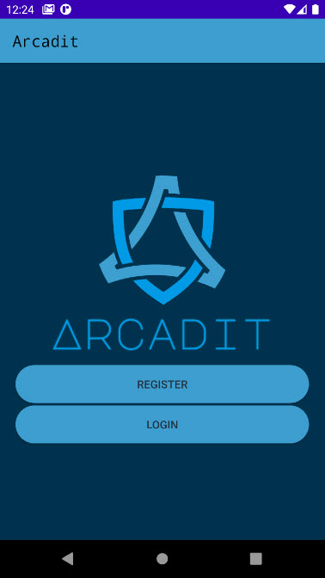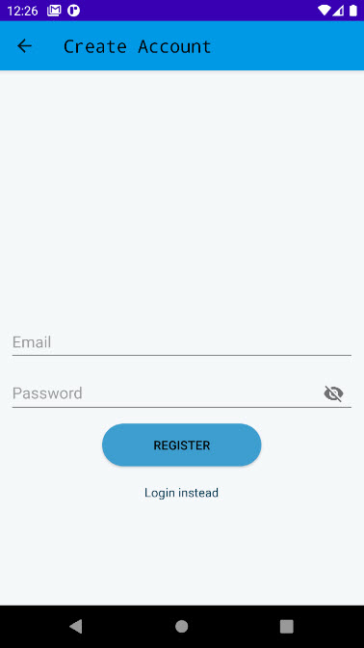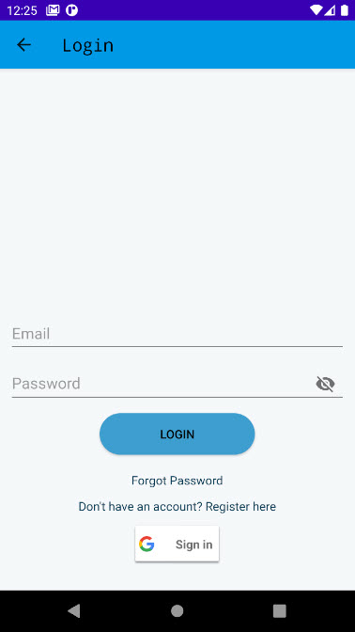Below are some screenshots of the application

